**QSMART – HG QUARTER WAVE PLATE REPLACEMENT**

**PROCEDURE**

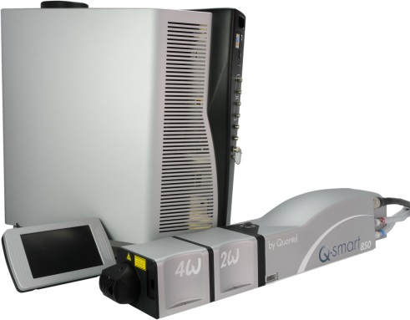

**Toolkit:**

Allen keys

**System**: QSMART

|  |  |
| --- | --- |
| **SM010370**  **SM010374** | **Q-SMART 2NDHG 1/4 WAVEPL ASSY**  **Q-SMART 3RDHG 1/4 WAVEPL ASSY** |

**Purpose**: This document details how to change the quarter wave plate.

|  |  |  |
| --- | --- | --- |
| Revision | date | modification |
| Initial issue | July 4, 2014 |  |
|  |  |  |
|  |  |  |
|  |  |  |

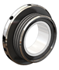

# DISASSEMBLY

* Remove the cover of the Harmonic generator (2 M3x6 BHC) and the protective cover (3 screws M3x6 BHC).

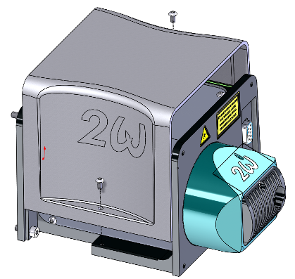 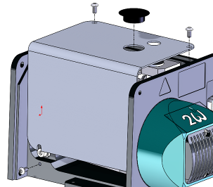

* Remove the assembly from the cover (2 screws CHC M4 * 8 + 2 washers ZU4)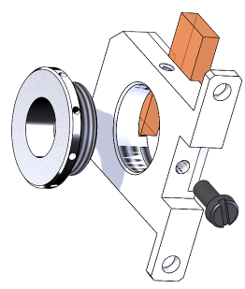 and the barrel.

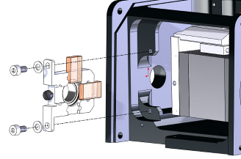

2 -Remove the barrel containing the ¼ wave plate.

1 - Loosen the barrel by unscrewing the CLS Nylon screws.

Remove the assembly

# IMPLEMENTATION OF THE QUARTER WAVE PLATE

|  |  |  |
| --- | --- | --- |
| 2.00 | V/CHC-M0408A2 | CHC M4X8 SCREW |
| 2.00 | R/ZU—D04—A2 | ZU4 WASHER |



Screw the barrel (The 4W and 5W configurations do not have barrel) in the holder. Do not screw to the maximum (leave at least one full turn).

Block cylinder with CLS Nylon screw. Be careful not to tighten too much.



3 W Position

Fix the assembly (2 CHC M4x8 + ZU4) as shown.

2 W Position



Attach the protective cover (3 screws M3x6 BHC). Clip the black cap on top.



Attach the generator cover (2 M3x6 BHC).